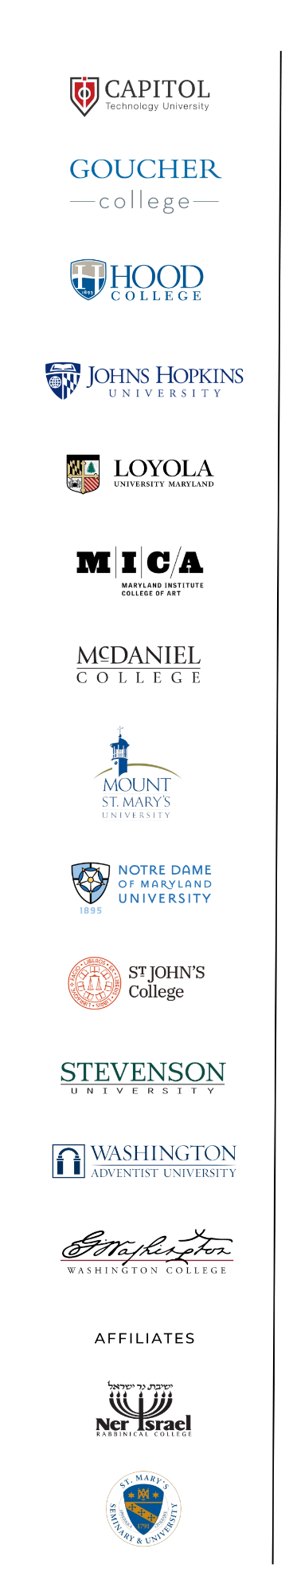
140 South Street, Annapolis, MD 21401
Written Support

Appropriations Committee

HB 1129 – (Rosenberg) Maryland Higher Education Outreach and College Access Program – Funding

Matt Power, President
mpower@micua.org
March 16, 2023

On behalf of the member institutions of the Maryland Independent College and University Association (MICUA) and the 56,000 students we serve, I thank you for the opportunity to provide this testimony in support of HB 1129 - Maryland Higher Education Outreach and College Access Program - Funding. This bill increases the annual appropriation for the Maryland Higher Education Outreach and College Access Program (program) from $200,000 to be $2 million. This increased funding will ensure that more low-income students have access to the supports and services that they may need to pursue their dream of higher education.
The program has been instrumental in increasing college access to low-income Maryland high school students and in helping them to complete a college education. Now more than ever, outreach efforts to encourage students to enroll in a college or university are vital to their future aspirations and career goals. Every Maryland student should be provided support services to educate them on the various post-secondary educational opportunities that exist after high school.

All institutions of higher education in Maryland, including the MICUA institutions, benefit from the program. Students who participate in the program are better prepared for college and future careers and are often recipients of Guaranteed Access Grant (GA) funding. MICUA member institutions are committed to helping students obtain the financial help they need to make private college affordable. Therefore, all thirteen of MICUA’s State-aided institutions participate in the Guaranteed Access Partnership Program (GAPP). GAPP is a public-private partnership program that helps close the affordability gap to attend a private institution. Students who receive a GA award from the State are eligible for a matching grant from the MICUA institution. Since 2017, GAPP has matched over $45 million to nearly 2,400 Maryland students.
We appreciate Delegate Washington’s commitment to making higher education accessible to low-income Maryland high school students through the Maryland Higher Education Outreach and College Access Program. If you have any questions or would like additional information, please contact Angela Sherman, Vice President for Academic Affairs, asherman@micua.org.

For all of these reasons, MICUA requests a favorable Committee report for House Bill 1129.

